AI-Based Smart Recipe and Dining Recommendation Platform
In today’s fast-paced world, people constantly face a seemingly simple yet recurring question —
“What should I eat today?”
Behind this question lies an imbalance of time, effort, and information:
- Sometimes people have ingredients in the fridge but don’t know how to use them.
- Other times, they crave a certain cuisine but don’t know how to cook or where to find it.
Traditional websites and apps only solve part of the problem. For example:
- SuperCook recommends recipes based on manually entered ingredients but cannot automatically recognize them or handle shopping/delivery.
- Jow can convert recipes into grocery lists and handle online purchases, but users must first select recipes—the system doesn’t understand what they already have or prefer.
So, our goal is to combine both concepts into a unified intelligent platform —
AI-Based Smart Recipe and Dining Recommendation Website
This system uses artificial intelligence and location-based services to bridge the gap between “What do I have?” and “What do I want to eat?”, helping users make faster, smarter dining decisions.
System Design & Features
- Fridge-to-Recipe Mode
Users simply take a photo of the ingredients in their refrigerator or kitchen, and the system automatically identifies the type, quantity, and freshness of the ingredients using computer vision models like the Google Vision API. Based on this identification, the system intelligently recommends recipes that are ready to cook right away. Users can view detailed cooking steps, watch AI-generated instructional videos, or add missing ingredients to their shopping list, saving time, reducing waste, and promoting a healthy and sustainable cooking experience.
2) Cuisine-to-Choice Mode
In this mode, users can either type or speak their preferences, such as: “I want Chinese food,” “I feel like eating something spicy,” or “I’m craving Italian cuisine.”
The system then combines location data, user history, and recipe databases to provide three intelligent options:
- Cook at Home – Recommends suitable recipes, generates an ingredient list, and allows users to place one-click grocery orders from nearby supermarkets.
- Order Takeout – Connects to food delivery platforms such as UberEats or DoorDash to suggest restaurants offering similar cuisines.
- Dine Out – Uses the Google Maps or others to recommend nearby highly rated restaurants and provides navigation assistance.
This feature elevates the platform from a simple “cooking assistant” to a comprehensive intelligent dining advisor, enabling users to move seamlessly from “what I want to eat” to “how to enjoy it” within just a few seconds.
Technical Implementation
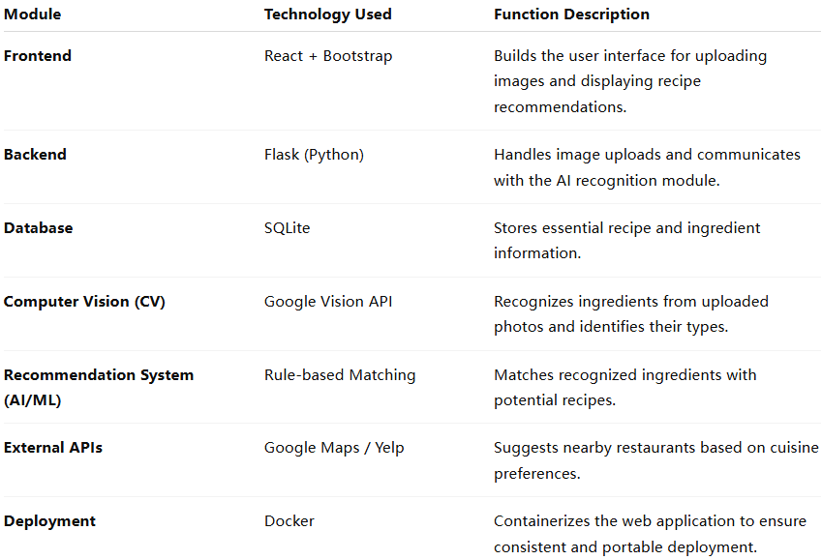

Ultimately, we aim to make “What should I eat today?” no longer a daily dilemma, but an easy decision powered by AI.

